Mole Valley Orienteering Club

(affiliated to the British Orienteering Federation)

NORBURY PARK “FROLICS” EVENT

Sunday 8th^{th} July 2001

Contact Jackie Olive 01737 212446

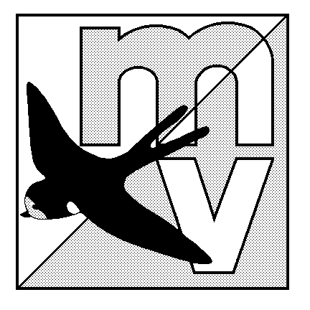

The Event will be using Sport-Ident electronic punching.

Directions: Young Street Car Park by the River Mole, off the A246 just West of its junction with the A24 near Leatherhead. Junction 9 of the M25 is just 3 miles away.
The car park is at Grid Ref : TQ163551.

Registration/Enquiries: This will be in the Car park. Registration 9.30 – 11.00.
There are 3 courses: Orange, Light Green and Green planned by Jon Smewing. Entry on the Day.

Frolics: This event is part of the Frolics series of events being held at areas around London. If you want to compete for your club you must run the Frolics course – the Light Green, you may run another course after this free of charge or for £1 if you want a new map.

Fees: £3.00/£1.00 (plus £1.00 for SI card hire and a £15 deposit or valuables (e.g.car keys) if required) There will be a parking fee of £1.00.

Starts: 10.00 – 11.30.

Map: The map scale is 1:15,000, updated in1998.

Terrain: Mainly undulating runnable woodland with steep scarp slope.

Results: Will be available on the Mole Valley web page (www.users.dircon.co.uk/~svogel) and by post.

Facilities: Squash will be available in the car park. There are NO toilets available, please go before you arrive.

Dogs: Welcome.

Please do not come to this event if you are in, or have to pass through, an area infected by Foot and Mouth.

COMPETITORS PARTICIPATE AT THIS EVENT AT THEIR OWN RISK.

